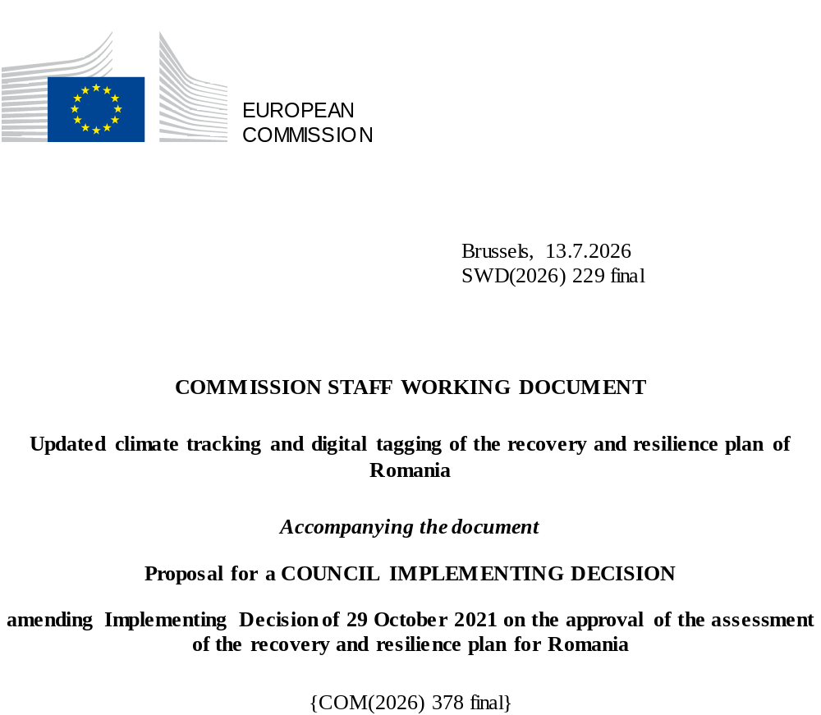

Executive summary
The modifications submitted by Romania under Article 21(1) of Regulation (EU) 2021/241 affect 92 measures in total. Romania requested to modify these 92 measures due to objective circumstances.
In addition, the proposed amendments to the Romania recovery and resilience plan aim to adapt the plan in line with the Communication from the Commission to the European Parliament and the Council “NextGenerationEU – the Road to 2026”.
Based on the assessment of the submitted modification, the Romanian modified plan receives an A-rating on all criteria except for costing, where the plan receives a B-rating (unchanged from the original plan assessment).

 | (1)  Balanced Response | (2)  CSRs | (3)  Growth, jobs… | (4)  DNSH | (5)  Green target | (6)  Digital target | (7)  Lasting impact | (8)  M & T | (9)  Costing | (10)  Control Systems | (11)  Cohe-rence | (12) REPowerEU | (13) Cross-border
A |  | A | A | A | A (39.1%) | A (24.0%) | A | A | B | A | A | A | A

Updated climate tracking and digital tagging of the recovery and resilience plan of Romania
The table below presents the detailed application of the climate tracking and digital tagging methodologies set out respectively in Annexes VI and VII to Regulation (EU) 2021/241 in the modified Romanian recovery and resilience plan.
Int. Field = intervention field.
Coeff. = Coefficient for the calculation of support to climate change objectives and to digital transition, on the basis of Annex VI and Annex VII of the RRF Regulation.

Measure  ID | Measure/  Sub-Measure Name | Budget  (EUR m) | Climate |  | Digital
Measure  ID | Measure/  Sub-Measure Name | Budget  (EUR m) | Int.  field | Coeff. % | Int.  field | Coeff. %
C1.I.4b | Rehabilitation of existing accumulations that require emergency interventions for safe operation | 33.00 | 40 | 40%
C1.I.5 | Appropriate endowment of river basin administrations for flood monitoring, prevention and emergency response | 1.60 | 035 | 100%
C1.I.5 | Appropriate endowment of river basin administrations for flood monitoring, prevention and emergency response - Other types of ICT infrastructure | 5.20 |  |  | 1.60 | 100%
C1.I.6 | Delivery of the water cadastre | 30.00 |  |  | 055 | 100%
C2.I.1 | Afforestation and reforestation national campaign, including urban forests | 306.88 | 035 | 100%
C2.I.2 | Modern production capacities of forest reproduction material | 50.00 | 035 | 100%
C2.I.3b | Identification of potential areas for strict protection in natural terrestrial and marine habitats in line with the EU Biodiversity Strategy for 2030 | 5.00 | 050 | 40%
C2.I.4d | Monitoring system for wild sturgeons along the Lower Danube | 3.99 |  |  | 055 | 100%
C2.I.5 | Integrated flood risk mitigation systems in forest river basins | 22.00 | 040 | 40%
C3.I.1a | Construction of voluntary collection centres | 240.11 | 042 | 40%
C3.I.1b | Establishment of integrated municipal waste management systems | 39.39 | 042 | 40%
C3.I.1b | Establishment of integrated municipal waste management systems | 33.37 |  |  | 055 | 100%
C3.I.1c | Establishment of integrated municipal waste management systems | 16.18 | 042 | 40%
C3.I.1c | Establishment of integrated municipal waste management systems | 0.56 | 044 | 40%
C3.I.1d | Establishment of integrated municipal waste management systems | 76.15 | 042 | 40%
C3.I.2 | Construction or delivery of infrastructure for manure and other compostable agricultural waste management | 47.01 | 044 | 40%
C3.I.3a | Public monitoring, control and institutional capacities for waste management | 0.36 | 042 | 40%
C3.I.3a | Public monitoring, control and institutional capacities for waste management | 11.97 |  |  | 055 | 100%
C4.I.1 | Modernisation and/or upgrading of railway infrastructure - Modernisation of TEN-T Core sections - Railway infrastructure construction | 364.89 | 064 | 100%
C4.I.1 | Modernisation and/or upgrading of railway infrastructure - Modernisation of TEN-T Comprehensive sections - Railway infrastructure construction | 353.12 | 065 | 100%
C4.I.1 | Modernisation and/or upgrading of railway infrastructure - “Quick wins” sections TEN-T Core | 366.46 | 067 | 100%
C4.I.1a | Modernisation and/or upgrading of railway infrastructure | 561.87 | 068 | 100%
C4.I.2 | Railway rolling stock - Electric Locomotives, EMU/HEMU railcars, wagon retraction | 241.64 | 072bis | 100%
C4.I.3 | Increasing the sustainability of road infrastructure on TEN-T network, road charging, traffic management - TEN-T Core sections (A1, A7) - ITS infrastructure | 8.06 |  |  | 063 | 100%
C4.I.3 | Increasing the sustainability of road infrastructure on TEN-T network, road charging, traffic management - Infrastructure for charging and control - digital | 101.15 | 063bis | 40% | 063 | 100%
C4.I.3a | Increasing the sustainability of road infrastructure on TEN-T network, road charging, traffic management | 47.90 |  |  | 063 | 100%
C4.I.5 | Increasing the road safety - ITS infrastructure (other then A1, A3, A7, A8) | 77.18 |  |  | 063 | 100%
C5.I.1 | Establishment of a renovation wave fund to finance works to increase the energy efficiency of the existing building stock - residential buildings | 323.73 | 025bis | 100%
C5.I.1 | Establishment of a renovation wave fund to finance works to increase the energy efficiency of the existing building stock - public buildings | 184.35 | 026bis | 100%
C5.I.1a.1 | Establishment of a renovation wave fund to finance works to increase the energy efficiency of the existing building stock - residential buildings | 680.32 | 025bis | 100%
C5.I.1a.3 | Establishment of a renovation wave fund to finance works to increase the energy efficiency of the existing building stock - public buildings | 700.00 | 026bis | 100%
C5.I.2 | Publication of the National Digital Building Register | 5.00 |  |  | 011 | 100%
C5.I.4 | Circular economy and increased energy efficiency of historical buildings | 5.05 | 026 | 40%
C5.I.4 | Circular economy and increased energy efficiency of historical buildings | 1.70 | 01 | 100%
C5.I.4 | Circular economy and increased energy efficiency of historical buildings | 5.00 | 023 | 40%
C6.I.2 | Green hydrogen production capacities for the use as electricity storage and/or for the decarbonisation of industry | 86.50 | 032 | 100%
C6.I.3 | Construction of flexible and highly efficient gas-fired electricity and heat generation (CHP) in district heating | 86.38 | 034 | 40%
C7.R.1 | Development of a unitary framework for defining the architecture of a government cloud system | 11.89 |  |  | 011 | 100%
C7.I.1 | Deployment of the Government Cloud Infrastructure | 374.73 | 011bis | 40% | 011bis | 100%
C7.I.2 | Cloud development and migration | 187.05 |  |  | 011 | 100%
C7.I.3 | Establishment of eHealth | 280.00 |  |  | 095 | 100%
C7.I.4 | Digitalisation of the judiciary | 127.31 |  |  | 011quater | 100%
C7.I.4 | Digitalisation of the judiciary - construction of energy efficient buildings | 35.00 |  |  | 025ter | 100%
C7.I.4 | Digitalisation of the judiciary | 80.00 |  |  | 011quater | 100%
C7.I.5 | Digitalisation in the field of the environment | 47.95 |  |  | 011 | 100%
C7.I.6 | Digitalisation in employment and social protection | 85.00 |  |  | 011 | 100%
C7.I.7 | Introduction of electronic forms (eForms) in the field of public procurement | 0.85 |  |  | 011 | 100%
C7.I.8 | Electronic identity card and digital signature | 109.40 |  |  | 011ter | 100%
C7.I.9 | Digitalisation of the non-governmental organisations sector | 12.00 |  |  | 010 | 100%
C7.I.10 | Digital transformation in civil service management | 10.00 |  |  | 011 | 100%
C7.I.11 | Support to the use of communication services in white areas | 94.00 |  |  | 054 | 100%
C7.I.12 | Ensuring cybersecurity protection for both public and private ITC infrastructures important for national security | 100.00 |  |  | 021quinquies | 100%
C7.I.13 | Development of security systems for the protection of the government spectrum | 28.86 |  |  | 055 | 100%
C7.I.14 | Increase of the resilience and cybersecurity of Internet Service Provider infrastructure services provided to public authorities in Romania | 18.39 |  |  | 021quinquies | 100%
C7.I.15 | Cybersecurity skills for the identified entities | 11.31 |  |  | 108 | 100%
C7.I.16 | Training programme for civil servants on digital skills | 20.00 |  |  | 108 | 100%
C7.I.17 | Digitalisation of libraries | 18.90 |  |  | 108 | 100%
C7.I.18 | Digital transformation and Robotic Process Automation in public administration | 5.00 |  |  | 011 | 100%
C7.I.18 | Digital transformation and Robotic Process Automation in public administration | 9.80 |  |  | 011 | 100%
C7.I.19 | Upskilling/reskilling of employees in firms | 19.00 |  |  | 108 | 100%
C8.I.1 | Facilitating taxpayers’ compliance through access to digital services | 4.20 |  |  | 011 | 100%
C8.I.2 | Improving tax and tax administration processes | 196.40 |  |  | 011 | 100%
C8.I.3 | Ensuring the capacity to respond to current and future information challenges, including in the context of the pandemic, through the digital transformation of Ministry of Finance / National Agency for Fiscal Administration | 78.50 |  |  | 011 | 100%
C8.I.4 | Establishment of electronic customs | 28.10 |  |  | 011 | 100%
C8.I.5 | Enhancing the budgetary programming mechanism | 3.57 |  |  | 011 | 100%
C8.I.5 | Enhancing the budgetary programming mechanism | 0.43 |  |  | 108 | 100%
C8.I.6 | Economic modelling instrument (Pension Reform Options Simulation Toolkit) to expand institutional capacity to forecast pension expenditures | 0.40 |  |  | 011 | 100%
C8.I.8 | Establishment of the National Development Bank - Other types of ICT infrastructure | 9.00 |  |  | 055 | 100%
C8.I.9 | Supporting the process of assessing pension files | 1.27 |  |  | 011 | 100%
C8.I.10 | Advanced e-services through digitalisation of the pension system | 61.88 |  |  | 011 | 100%
C9.I.1 | Digital platforms on legislative transparency, de-bureaucratisation and procedural simplification for business. | 5.30 |  |  | 011 | 100%
C9.I.2d | Financial instruments for the private sector - Fund of funds for digitisation, climate action, and other areas of interest and Financial instruments for the private sector - Digitising SMEs | 16.00 |  |  | 010 | 100%
C9.I.2d | Financial instruments for the private sector - Fund of funds for digitisation, climate action, and other areas of interest and Financial instruments for the private sector - Low carbon economy | 33.00 | 027 | 100%
C9.I.3a | Private sector aid schemes - Aid scheme for the digitalisation of SMEs | 212.50 |  |  | 010 | 100%
C9.I.3a | Private sector aid schemes - Aid scheme for the digitalisation of SMEs - Investments in advanced technologies | 44.00 |  |  | 021quater | 100%
C9.I.4 | Cross-border and multi-country projects - Low Power Processors and Semiconductor Chips | 400.00 |  |  | 021quater | 100%
C10.I.1 | Sustainable urban mobility - Clean urban transport rolling stock | 580.00 | 074 | 100%
C10.I.1 | Sustainable urban mobility - ITS | 100.00 |  |  | 076 | 100%
C10.I.1 | Sustainable urban mobility - Other ICT infrastructures | 175.00 |  |  | 021ter | 100%
C10.I.1 | Sustainable urban mobility - Recharging points for electric vehicles | 25.00 | 077 | 100%
C10.I.1 | Sustainable urban mobility - Cycling lanes constructed | 69.56 | 075 | 100%
C10.I.2 | Construction of housing for youth and for professionals in health and education - Construction of energy efficient buildings | 57.31 | 025ter | 40%
C10.I.2 | Construction of housing for youth and for professionals in health and education - Other types of ICT infrastructure | 0.50 |  |  | 055 | 100%
C10.I.3 | Renovation of public buildings to support better public service delivery by administrative territorial units | 220.93 | 026bis | 100%
C10.I.3a | Renovation of public buildings to support better public service delivery by administrative territorial units | 287.50 | 026bis | 100%
C10.I.4 | Producing/updating in GIS format of spatial planning and urban planning documents | 17.26 |  |  | 011 | 100%
C11.I.1 | Promotion of the 12 touristic/ cultural routes | 9.98 |  |  | 011 | 100%
C11.I.4 | Construction of at least 236 km of cycling routes | 24.30 | 075 | 100%
C11.I.6 | Establishment of digital system for cultural funding processes | 3.75 |  |  | 011 | 100%
C11.I.7 | Accelerating the digitalisation of film production and distribution | 5.46 |  |  | 021bis | 100%
C12.I.1 | Pre-hospital medical infrastructure | 10.97 | 025ter | 40%
C12.I.2 | Public hospital infrastructure | 11.19 |  |  | 095 | 100%
C12.I.2 | Public hospital infrastructure | 91.27 | 025ter | 40%
C12.I.3 | Public hospitals | 75.00 | 095 | 40%
C12.I.3 | Public hospitals | 7.00 |  |  | 025ter | 100%
C13.I.3 | The establishment of the labour voucher system for domestic providers and service beneficiaries | 4.03 |  |  | 055 | 100%
C14.R.1 | Enhancing the quality of government decision-making | 2.80 |  |  | 011 | 100%
C14.R.2 | Increasing strategic governance for climate and sustainable development and environmental policies | 5.23 |  |  | 011 | 100%
C14.R.3 | Modernising human resources management in the public sector | 5.00 |  |  | 011 | 100%
C14.R.9 | Improve the procedural framework for the implementation of corporate governance principles in state-owned enterprises | 1.46 |  |  | 011 | 100%
C14.I.5 | Monitoring and implementation of the plan | 12.84 |  |  | 011 | 100%
C15.I.1a | Construction and equipping of crèches of 80 crèches - construction of new energy efficient buildings | 137.45 | 025ter | 40%
C15.I.1b | Construction and equipping of crèches of 30 crèches - construction of new energy efficient buildings | 51.55 | 025ter | 40%
C15.I.2 | Setting up, equipping and approving complementary services | 0.26 |  |  | 012 | 100%
C15.I.4 | Supporting educational establishments with medium and high risk of drop-outs - part of digitalisation | 96.00 |  |  | 012 | 100%
C15.I.6 | Building and equipping vocational campuses within regional consortia - Construction of new energy efficient buildings | 140.00 | 025ter | 40%
C15.I.6 | Building and equipping vocational campuses within regional consortia - IT services and applications for digital skills | 16.90 |  |  | 012 | 100%
C15.I.8 | Digital pedagogy training programme(s) for teaching staff | 80.00 |  |  | 108 | 100%
C15.I.9 | Digital equipment and technological resources for schools and extracurricular educational establishments | 478.50 |  |  | 108 | 100%
C15.I.10 | Green-schools network development and purchase of green minibuses - Energy renovation | 9.14 | 026 | 40%
C15.I.10 | Green-schools network development and purchase of green minibuses - Construction of new energy efficient buildings | 52.96 | 025ter | 40%
C15.I.10 | Green-schools network development and purchase of green minibuses - Purchase of electric minibuses | 200.00 | 074 | 100%
C15.I.11 | Provision of equipment for pre-university classrooms and school science laboratories/school cabinets - Part of digital laboratories | 60.00 |  |  | 012 | 100%
C15.I.13 | Equipping of IT laboratories in vocational education and training (VET) schools | 9.00 |  |  | 012 | 100%
C15.I.14 | Equipping of practice workshops in VET schools - Digitisation part | 16.50 |  |  | 012 | 100%
C15.I.16 | Digitisation of universities and their preparation for the digital professions of the future - Universities | 234.00 |  |  | 108 | 100%
C15.I.17 | Ensuring university infrastructure (accommodation, canteens, recreation facilities) - Construction of new energy efficient buildings | 66.64 | 025ter | 40%
C15.I.17 | Ensuring university infrastructure (accommodation, canteens, recreation facilities) - Energy renovation | 69.16 | 026 | 40%
C16.R.1 | Creating a legal framework for the use of state land as acceleration areas for RES investments - digital tagging* | 0.76 |  |  | 011 | 100%
C16.I.2 | New capacities for electricity generation from renewable sources | 460.00 | 029 | 100%
C16.I.4 | Grant Vouchers to accelerate the rollout of renewable energy by households | 610.76 | 029 | 100%
C16.I.5 | Digitalisation and modernisation of the national electricity transmission network | 29.56 | 029 | 100%
C16.I.5 | Digitalisation and modernisation of the national electricity transmission network* | 11.20 |  |  | 010bis | 100%
C16.I.5 | Digitalisation and modernisation of the national electricity transmission network - Teletrans SA* | 8.44 |  |  | 055 | 100%
C16.I.7 | Grant Vouchers to support households’ energy efficiency upgrades - Axis I - PV | 156.97 | 029 | 100%
C16.I.8 | Contracts for Difference allocation | 62.04 | 028 | 100%
C16.I.9 | Industrial chain of production and/or assembly and/or recycling of batteries, cells and photovoltaic panels (including ancillary equipment), production of raw materials used in the associated industry, and new electricity storage capacities – Electricity* | 80.00 | 033 | 100% | 033 | 40%
C16.I.10 | Ensuring energy efficiency in the industrial sector | 64.00 | 024ter | 100%
* Reforms and investments in the REPowerEU chapter are not taken into account when calculating the plan’s contribution to the digital target requirement set by Regulation (EU) 2021/241.

4.6.2025 COM(2025) 310 final

